Breakout Room Discussion of Session 9 Exercises

In each of your groups, you’ll be discussing the Session 9 exercise questions.

First, decide which roles each group member will fill:

Roles:
Moderator - helps facilitate the conversation and encourages equitable participation
Timekeeper - keeps the group on track
Note Taker - takes record of the group’s discussion in this Google doc (see below).
Active Participant – engages and contributes to the discussion.
Reporter - presents the group’s solution to the whole class when we regroup.

Before you begin to answer the exercise questions:
- Introduce yourselves briefly.
- Assign roles and record them below. Try to take a different role than last time.
- Discuss the question(s) assigned to your group and note your answer.
- Next, discuss other questions from Session 9. You won’t need to present these to the class but can use this time to compare answers to the other Session 9 questions.

Breakout Room (n=5 per room)
Breakout Room | Assigned Exercise Questions (see next page)
1 | S9Q1
2 | S10Q1,Q2
3 | S10Q3
4 | S10Q4
5 | S9Q1
6 | S10Q1,Q2
7 | S10Q3
8 | S10Q4
9 | S9Q1
10 | S10Q1,Q2
11 | S10Q3
12 | S10Q4

Roles:
- Moderator -
- Timekeeper -
- Note Taker -
- Reporter -
- Active Participant -

Question discussed:

Solution to assigned question:

Any question you want the whole class to discuss/answer?

A different question discussed:

Notes:

Session 9 Exercise

- Suppose you are interested in the number of times an experiment works before it fails. Suppose it failed on the first try, then on the sixth try, then on the first try.
Therefore, the data are: (0, 5, 0).
What is a bootstrapped estimate of the median number of successes before failures, and the standard error in your estimate?

To help, here are 10 bootstrap samples:
{0, 0, 5}
{5, 0, 0}
{5, 0, 5}
{0, 5, 0}
{0, 0, 5}
{5, 5, 0}
{0, 5, 0}
{0, 5, 5}
{0, 5, 5}
{5, 0, 5}

Session 10 Exercises
- Name at least two other possible summary statistics that could be used to test the hypothesis H₀: p_{v} = p_{p}
- The following table provides the data from Pauling’s vitamin C study and below that is a stem and leaf plot of the randomization distribution (n = 1000) of the relative risk (RR)from the trial. Find the p-value for testing Ho: RR < 1.
Reading a stem and leaf plot:  Each entry gives a RR to 2 digits; the first digit is to the left of the |; the numbers to the right of the | are the second digits. For example, the smallest RR is .34 and the five next smallest are .46. | Cold - Y | Cold - N | Total
Vitamin C | 17 | 122 | 139
Placebo | 31 | 109 | 140
Total | 48 | 231 | 279

.3 | 4
.4 | 66666
.5 | 0000055555555555555
.6 | 00000000000000000000000006666666666666666666666666666666666666
.7 | 22222222222222222222222222222222222222222222222222222222222222222222+63
.8 | 55555555555555555555555555555555555555555555555555555555555555555555+12
.9 | 33333333333333333333333333333333333333333333333333333333333333333333+28
1.0 | 11111111111111111111111111111111111111111111111111111111111111111111+152
1.1 | 99999999999999999999999999999999999999999999999999999999999999999999+15
1.2 | 99999999999999999999999999999999999999999999999999999999999999999999+9
1.3 | etc
- Describe a permutation test to test the hypothesis Ho: ρ = 0 (no association). What test statistic would you use? How would you find the permutation distribution of that test statistic when Ho is true?
- Here is a plot of 1000 p-values. Use these data to estimate (by eye) the number of true null hypotheses (m₀) and then use that to complete the table below (assume α = .05)
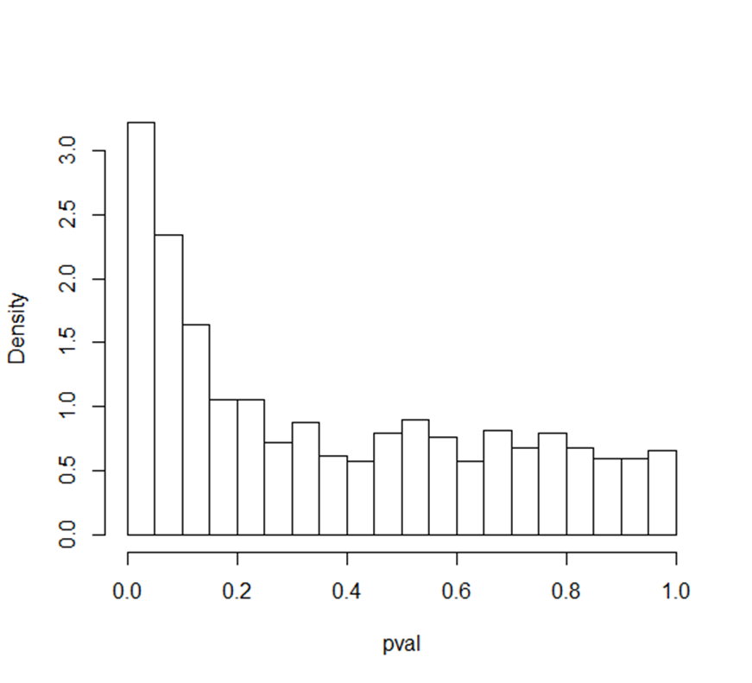
 | Reject null | Fail to reject
Null true
Alternative true
 | 161 | 839 | 1000

